VDP Instructions:

Select your item in our webshop and press the order button:
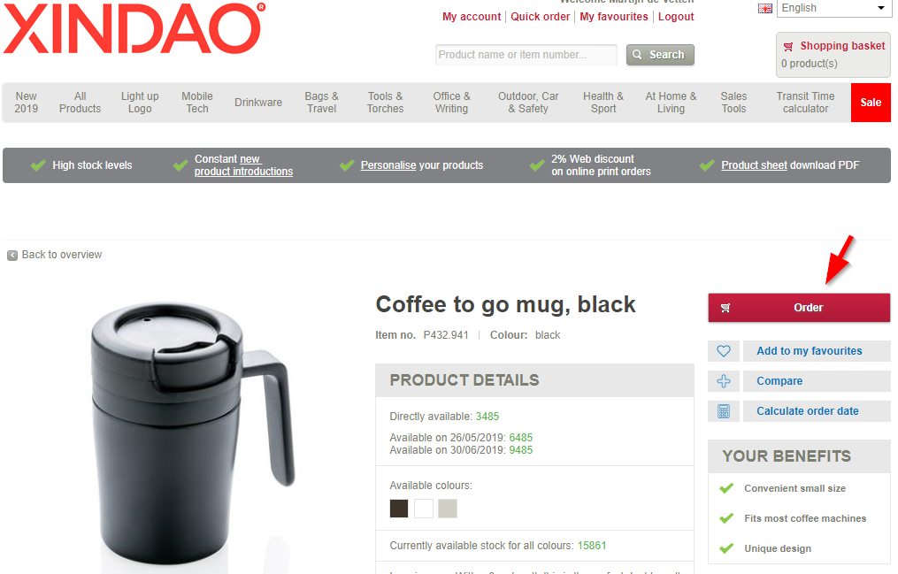

Add a decoration and indicate that you want to engrave or print variable data on that position. The VDP option is only shown on those techniques that are suited for individual personalisation.
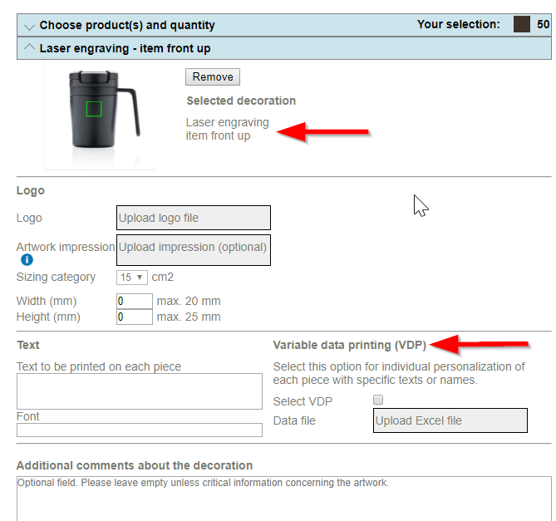

Upload an Excel file with the individual data to be printed.
The file should ONLY be filled with data that varies per piece!

In case of single names where the first and the last name of the person need to be engraved, the Excel sheet should look like this:
Name line 1 | Name line 2
Peter | Parker
Nathalie | Jean

Or like this in case of a double first name:
Name line 1 | Name line 2 | Name line 3
Peter | Parker
Nathalie | Jean
Marie | Antoinnette | Roger

For sleeves the individual text can be longer:
Name line 1 | Name line 2 | Name line 3 | Text sleeve front
Peter |  | Parker | We are happy to have you on board!
Nathalie |  | Jean | Congratulations on your anniversary!
Marie | Antoinnette | Roger | Thank you!

IMPORTANT NOTES:
- All names should be placed in a separate cell in the Excel sheet
- The font shown in the Excel file will be used for printing
- The max point size for the chosen print position will be calculated by our DTP department based on the longest name (or text) from the list
- All names from the list will be engraved/printed in the same font and point size
- In case the first name of a person is a double name, with more characters than other names in the list, it is advised to split the name over 2 columns so that they will be engraved / printed in 2 lines
*Most used/advised fonts for VDP: Helvética, Arial, Futura, Minion, Frutiger, Calibri, Myriad, Interstate, Gotham, Times New Roman
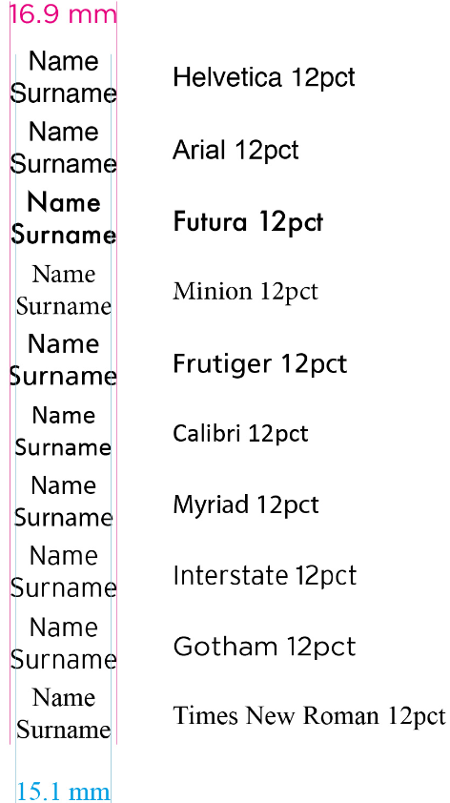

ATTENTION! For the embroidery of individual names or texts, only the below fonts can be used:
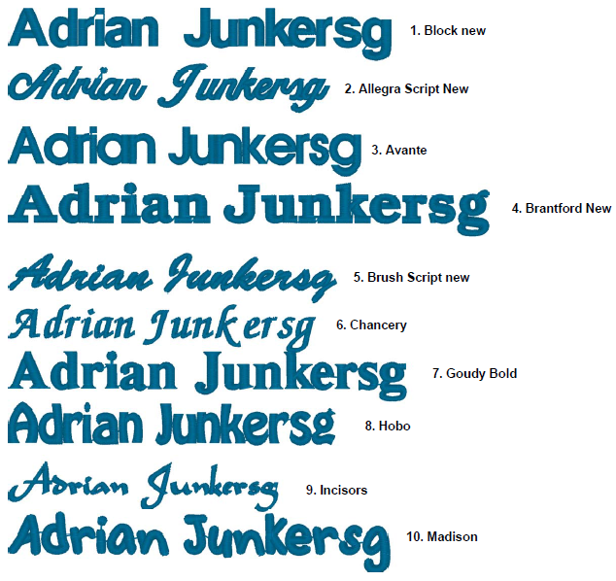

Price calculation VDP orders/quotations:

Logo + individual personalisation
1x engraving/printing costs per piece
1x engraving costs per piece + 1x VDP costs per piece
2x setup

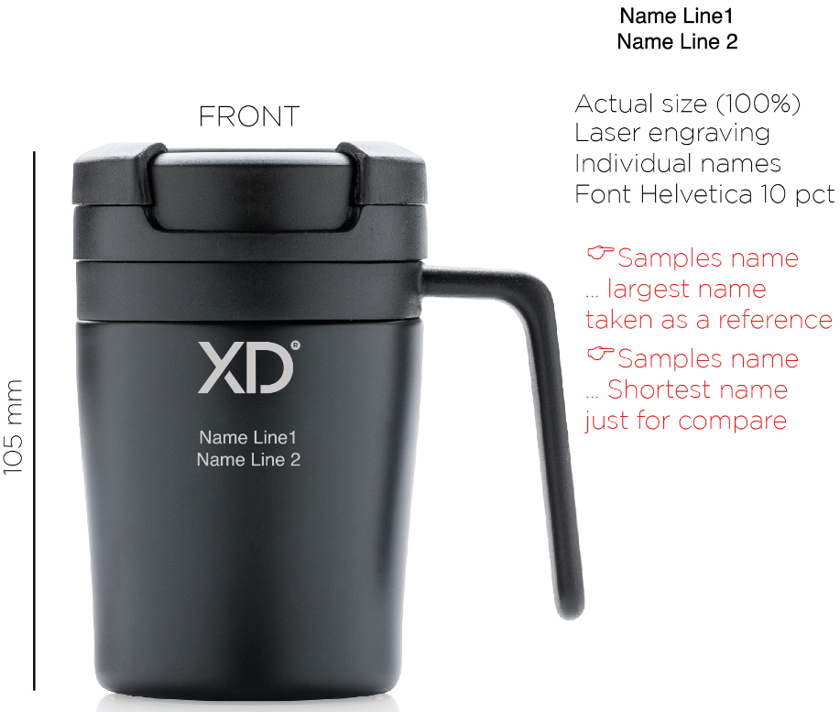

Logo in technique 1/position 1 + individual personalisation in technique 2/ position 2 + Sleeve with VDP
1x engraving/printing costs per piece
1x engraving costs per piece + 1x VDP costs per piece
1x sleeve costs per piece + 1x VDP costs per piece
3x setup

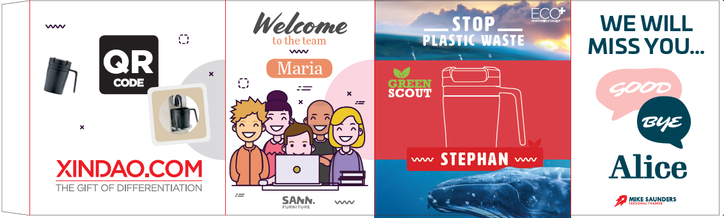

As a true finishing touch, we can gift wrap the items for you. The gift wrapped items will have a sticker on the top with the individual name that is on the item or the sleeve, printed on the sticker.

